

Submitted By:
Fatima Saeed -2026-CYS
Assignment:
Lab No.1
Submitted To:
Sir Mujtaba Kamal
For the fulfillment of,
Programming Fundamental Lab
Department of Computer Engineering
University of Engineering and Technology, Lahore

Task No.1: Code
print("Name :Fatima Saeed")
print("Department :Computer Engineering")
print("University : UET Lahore")

Output
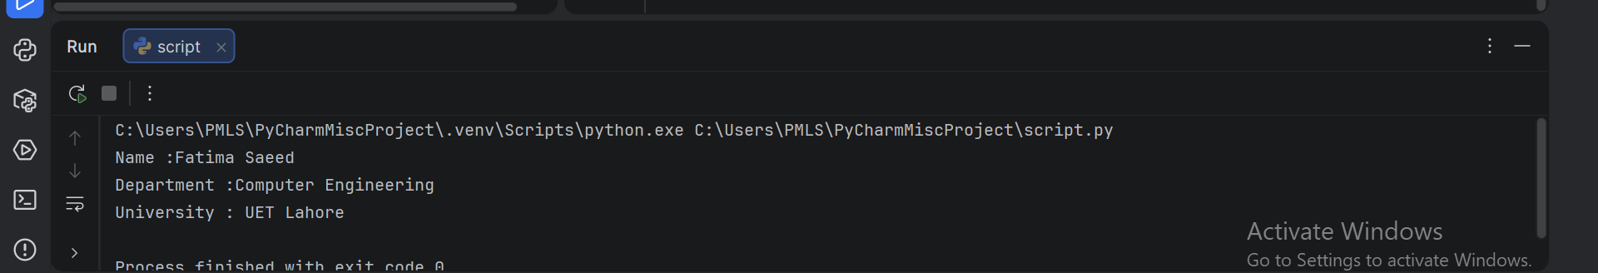
Task No.2: Code
print( "UET", "Lahore", "Computer", "Engineering", sep="-")
Output
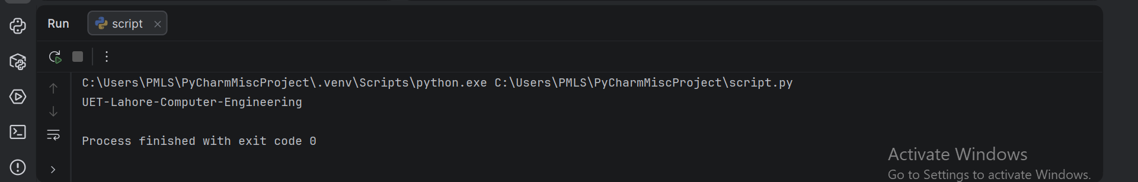

Task No.3: Code
print(" Name: Fatima\nAge: 20\nCity: Lahore")
Output
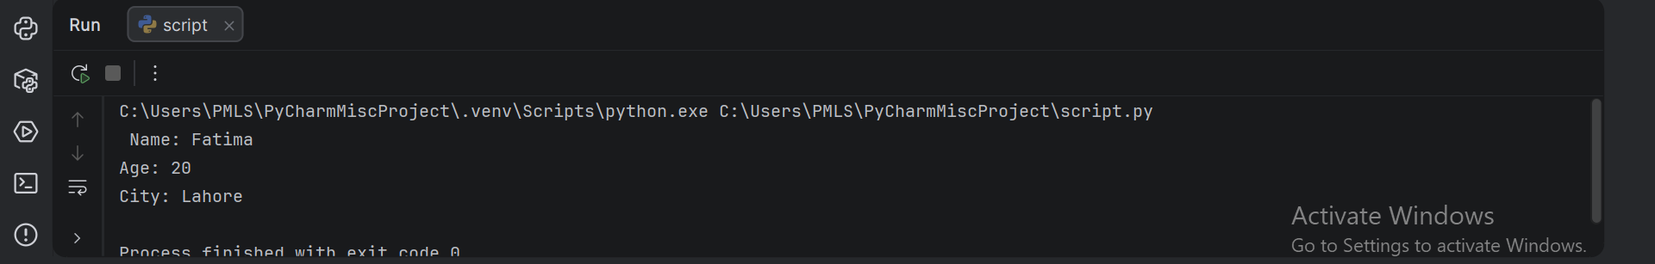
Task No.4: Code
name = input("Enter Your Name:")
age = int(input("Enter Your Age"))
print ("name:" , name )
print ("Your age" , age )
Output
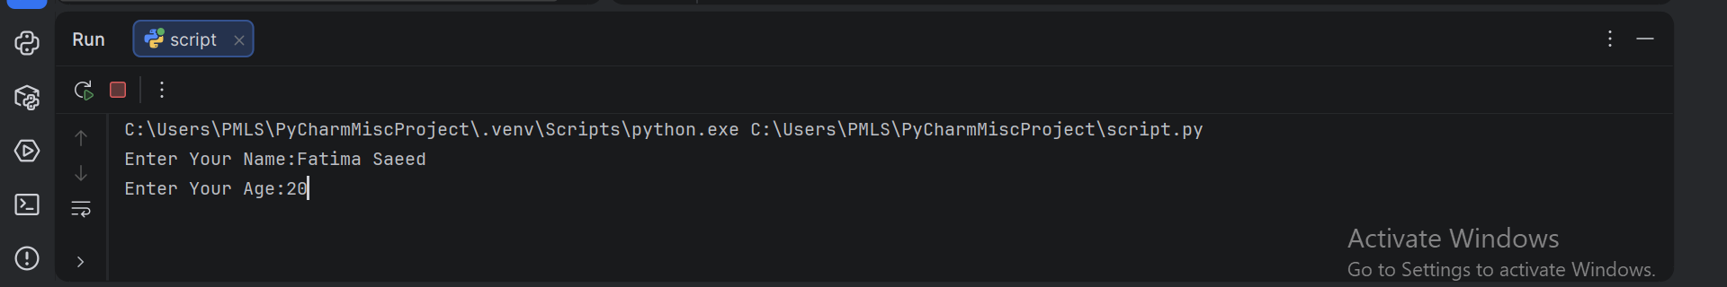
Task No.5: Code
x = 10
y = 3.14
z = True
name = "UET"
print(x)
print(y)
print(z)
print(type(x))
print(type(y))
print(type(z))
print(type(name))
print(len(name))

Output
